Title in Bold Helvetica 16 pt

A. N. AuthorOne¹, A. N. AuthorTwo², A. N. AuthorThree²

¹Institution A, Postal address
Email: name1@not.as.a.hyperlink.please

²Institution B, Postal address
Email: {name2; name3}@not.as.a.hyperlink.please

Abstract
An abstract for short peer-reviewed papers should be presented in Times New Roman typeface, 12 pt font. The abstract should not exceed 150 words.

1. Introduction
This document provides a template for extended abstracts submitted to SAM for the student paper competition. We base this template on the format used in past GIScience meetings. Given length constraints, these papers should be as complete as possible.
The title should be Helvetica and 16 pt with mixed capitalization. The author names must be in Times New Roman (12 pt) and the affiliations Times New Roman (8 pt). If multiple authors share the same affiliation, “share” the affiliation and list e-mail addresses as {persona; personb}@email.com. Email address should not be listed as hyperlinks.
The page size must be US Letter with margins of 2.54cm (1 in) on all sides. Each section of the paper (except the Acknowledgements and References sections) should be numbered, as shown in this example. The section heading should be left-aligned with bold Helvetica 14 pt.
The main text is set in Times New Roman 12 pt. The main text should just be justified. The first line of the first paragraph in each section or subsection should not be indented. The rest of the paragraphs should be indented by 0.635cm (0.25 in), as in this example. Use only one space between sentences.
Extended abstracts should be written in English. Authors should limit their abstracts to a maximum of 1500 words (for a sense of length, this template is ~980 words). In addition, all submitted abstracts must include a one-page Letter of Support from a faculty sponsor. Submissions that fail to follow the specified format, prescribed length, or that do not include a Letter of Support, will not be considered for inclusion.

1.1 Subsections and Their Formatting
Subsections should be numbered as shown in this example. The subsection heading should be left-aligned with bold Helvetica 12 pt. The use of sub-subsections is discouraged for short peer-reviewed papers.

2. Equations, Figures and Tables

2.1 Equations
Equations should be centred on the page and numbered consecutively in the right-hand margin as (1), (2), etc. They should be referred to in the text as follows: “Equation 1 is applied to compute ...” or “Weighted correlation coefficient (2) is used for ...”.

2.2 Figures
Figures should be presented at relevant locations in the text and not at the end of the paper. They should be referred to in the text (e.g., “Figure 1 shows the venue for the 2017 AAG AGM”). The figure caption should be bolded, centred and placed below the figure. It should end with a full stop. As can be seen with Figure 1, figures are centred on the page.

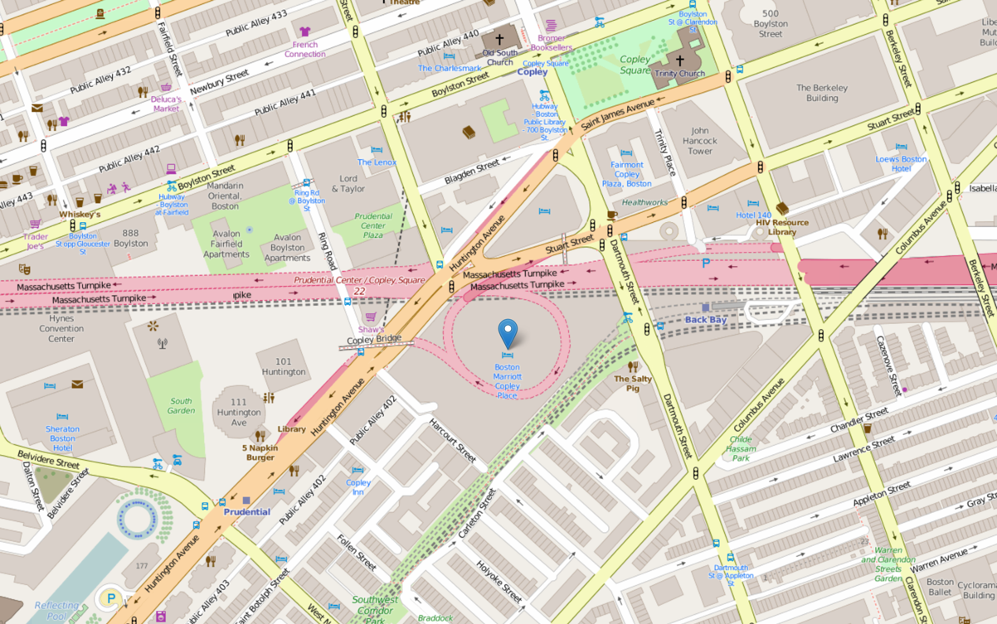
Figure 1. The venue for the AAG AGM 2017.

Colour figures are acceptable since the extended abstracts will be distributed in digital format. The authors also should ensure that the figures conform to a minimal sufficient quality for reproduction: 200 dpi for images and 300 dpi for drawings.

2.3 Tables
Tables should be in the style shown below and should be referred to in the text using table numbers such as Table 1. The table caption must be bolded, centred and placed above the table. The lines at the top and the bottom end of the table are 1 pt, the line separating the header from the body of the table is 0.5 pt. Similar to figures, tables are centred on the page. Please minimize whitespace in your paper with suitable placement of figures, tables, and text.

Table 1. Recent SAM board members.
Year | Chair | Vice Chair | Board members
2016/2017 | Heejun Chang | Carson Farmer | Eun-Hye Enki Yoo, Debs Ghosh, Daoqin Tong
2015/2016 | Heejun Chang | Anthony Grubesic | Jennifer Miller, Eun-Hye Enki Yoo, Debs Ghosh
2014/2015 | Li An | Anthony Grubesic | Jennifer Miller, Eun-Hye Enki Yoo, Yongwan Chun
2013/2014 | Li An | Anthony Grubesic | Jennifer Miller, Joni Downs, Yongwan Chun
2012/2013 | Li An | Fang Qiu | Changjoo Kim, Joni Downs, Yongwan Chun

3. References and Citations
A list of references cited must be provided at the end of the paper. Citations within the text should be given as follows. There are several good papers in this area (Authority 1973; Learned and Expert 1982), although the work by Fudgit et al. (1997) is an exception. Note that “et al.” is italicised. Do not insert a comma between author(s) and year. A citation with page number should be made as in Learned and Expert (1982: 121).
The reference list should be formatted as in the example below, using 10 pt Times New Roman, aligned to both left and right margins, and 0.635cm (0.25 in) hanging paragraphs for each reference. Do not use abbreviations of journal titles.

4. File Format and Submission
Short peer-reviewed papers should be submitted as PDFs or Word documents via email to Eun-Hye Enki Yoo (eunhye@buffalo.edu). Manuscripts must not contain header or footer information and must not include page numbers.

Acknowledgements
Acknowledgements (not required) may be made of any funding bodies who have supported the work reported in the paper, of those who have given permission for their work to be reproduced, or of individuals whose particular assistance is due recognition.

References
Authority F, 1973, Stating the obvious: An interdisciplinary approach. Journal of Entirely Predictable Results, 63(2):1037–1068.
Fudgit B, Publish HWP and Writer AB, 1997, Looming deadlines and how to deal with them. Partridge & Co, Norwich, UK.
Learned C and Expert M, 1982, Reworking previous publications for fun and profit. In: Doctor K and Professor B (eds), Proceedings of the 2nd International Conference on Something You Thought Was Relevant But Isn’t Really, Los Angeles, USA, 120–149.

